Chapter-1: Introduction

Our project is all about “FABRICATION OF QUADCOPTER” where a drone is used for multiple purpose such as UAV in Military for rescue missions or in Agriculture purpose.
Our Project idea presents Automation in Auto Mobile Industry.

  - Project Summary

This project is about “Fabrication of Quadcopter”. In this project we have provide user Friendly Quadcopter.
We are using circuit in this project like:
- KK 2.1.5 Flight Controller
- OrangeRx-R615x Receiver
- Spektrum DX5e Transmitter
- Chassis & Propellers
- 4x ESC (Electronic Speed Controller)
- 2200kv LIPO Battery
- 4x 1400kv Brusless Motors

1.2 SCOPE:
- Most important advantages that it can work in rescue missions or military purpose.
- Device can also be used as children toys.

  - OBJECTIVE:

The main objectives of our Project Fabrication of Quadcopter are that it can be used as UAV in Military.

Most interesting thing about this project is that it can be used in agriculture purpose.

Chapter-2: System Requirements Study

2.1 USER CHARACTERISTICS:
- User should have basic information about how to operate a 5 channel receiver.
2.2 Tools & Technology Used:
2.2.1 User Interface:
5 channel Controller.
2.2.2 Hardware Interface
KK 2.1.5, Transmitter, Receiver, Brushless Motors
2.2.3 Software Interface
KK 2.1.5

Chapter-3: System Design

3.1 Project Flow:

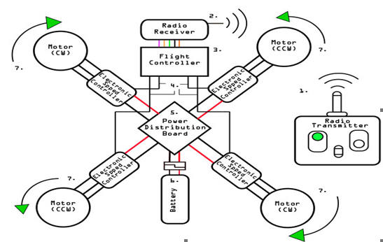

3.2 Major Functionality:
A typical unmanned aircraft is made of light composite materials to reduce weight and increase maneuverability. This composite material strength allows military drones to cruise at extremely high altitudes.
Drones are equipped with different state of the art technology such as infra-red cameras (military UAV), GPS and laser (military UAV). Drones are controlled by remote control system also sometimes referred to as a ground cockpit.
An unmanned aerial vehicle system has two parts, the drone itself and the control system.
The nose of the unmanned aerial vehicle is where all the sensors and navigational systems are present. The rest of the body is full of drone technology systems since there is no need for space to accommodate humans. The engineering materials used to build the drone are highly complex composites which can absorb vibration which decreases the noise produced and also light weight.

Chapter-4: Implementation Planning

  - Implementation Environment:

  - Our project has Single User

4.2 Module Specification:
- Car Module:

  - We have joined flight controller circuit, arduino circuit and orange receiver circuit in drone.
  - Flight controller circuit will be connected with ESC and it will sway the four motors.
  - Orange receiver circuit will transfer data to flight controller circuit in analogue form.
  - Orange receiver circuit will receive data from spektrum transmitter in binary form.

- Remote Controller Module:

- We will use spektrum transmitter as our Remote controller.
- 5 channels are used for input purpose.
- Spektrum transmitter is used for output purpose.
- Arduino circuit is used for converting input data to output data by Arduino coding system.
- 2200kv Lipo battery is applied.

  - Project Gallery:

    - Flight Controller CKT:

KK 2.1.5 is a board with ATMEL mega 664PA,8-bit AVR RISC based microcontroller with 64K of memory.It is easy for the beginner to start with and has firmware pre-defined in it. While activating or deactivating the board there is an audio warning from the piezo buzzer of KK 2.1.5.It is one of the most stable board because it has inbuilt gyroscope 6050 MPU, and auto level function. This board has eight motor outputs, five control inputs, an LCD display, polarity protected voltage sensor input, six-axis accelerometer/gyroscope, a fuse protected piezo output. The user-defined signals from K.K.board and are passed to the ESC's installed on the frame of the drone.

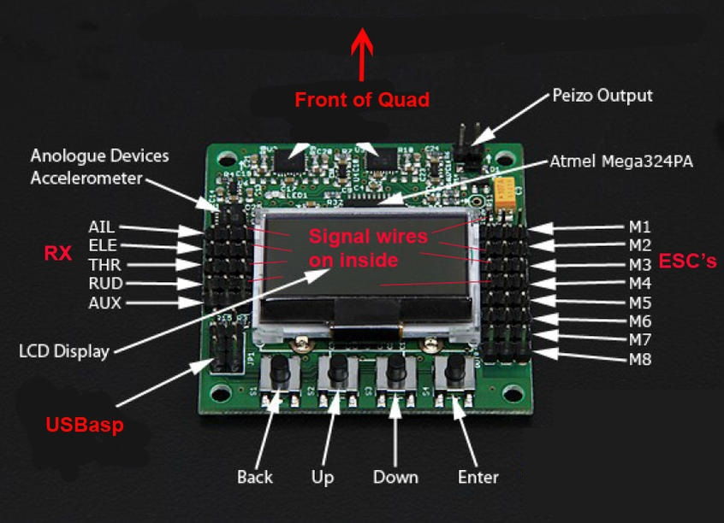

    - RF Transmitter & Reciever:

The Transmitter acts as a controller from the user. It is a radio communicating wireless control system. The signal from the transmitter is received by the receiver placed on the frame of Drone through the antenna in a receiver. The signal from a receiver is given to KK board. This board will send the signal to all electronic speed controller from that speed of the motor is controlled by the transmitter. The modulation scheme used in between transmitter and receiver is pulse position modulation (PPM).
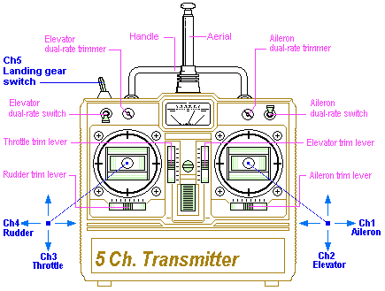

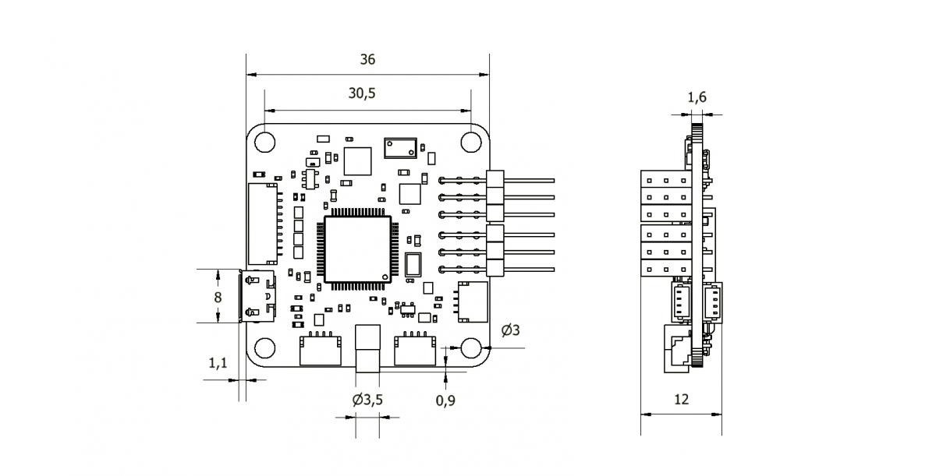
    - ESC (Electronic Speed Controller):

An electronic speed controller is an electronic device used to control the speed of the motor and the direction also. It follows a speed reference signal and varies the switching rate of field effect transistors. By adjusting the duty cycle or switching the frequencies of the transistor the speed can be changed.

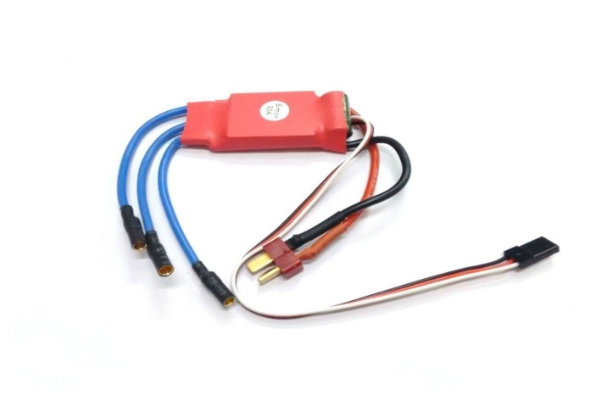

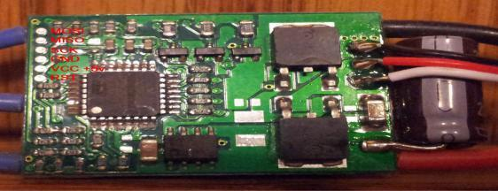

    - Arduino:

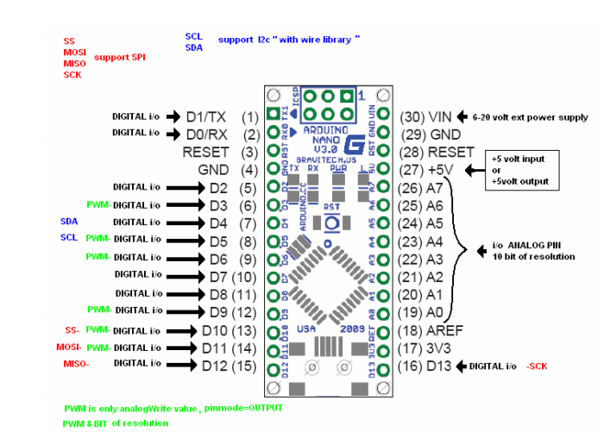

    - Battery:

Lithium polymer battery 2200kv or Lipo battery is a simple rechargeable battery with different current ratings and number of cells. Here lithium ion adds to the polymer which is an electrolyte.

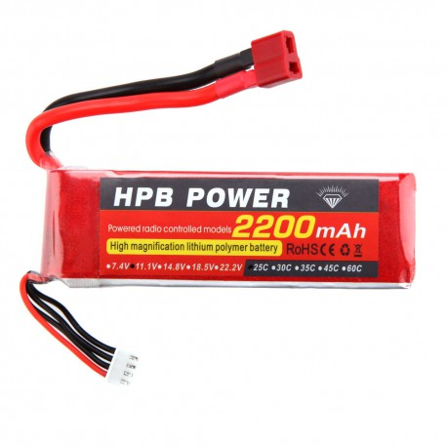
    - Brushless DC Motor:

DC motor 1400kv is a type of synchronous motor that is powered by DC source via an inverter to produce an AC electric current to drive each phase of the motor. Its construction is simple as permanent magnet synchronous motor. The advantage of this motor is High speed and electronic control.

Kv(rpm/v) | 1000
Max.Power | 920W
ESC | 30A
Weight | 150 gms
Battery | 3S-5S Lipo
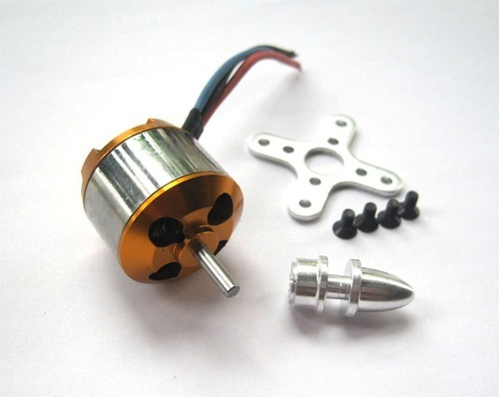

Specification of Brushless DC Motor

    - Propellers:

These are simply fans which convert the motion of the motor into upward thrust. They are, made up of flexible fibre to be unbreakable while crash landing.

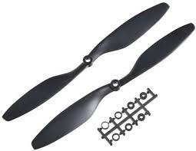

Inches | 10inch
Thickness | 0.45 inch
Diameter | 0.8 inch
Weight | 22 gms
Type | Pusher | &puller
 | pair

    - Frame:

These are many types of frames for Drone. They are made of fibre & has integrated PCB for soldering ESCs and battery wires. Different colour coding made us know the orientation of the Drone.

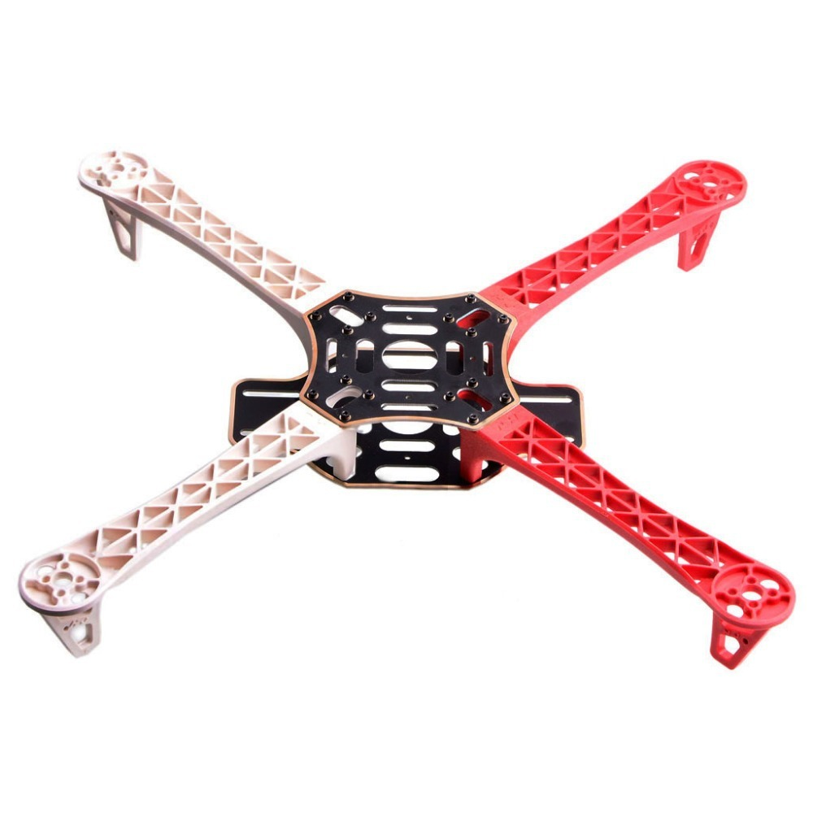

Chapter-5: Limitations and Future Enhancement

5.1 LIMITATIONS:
In our project remote frequency is up to 500 Meter, so after 500 meter drone will stop working.
5.2 FUTURE ENHANCEMENT:
Our project can use in UAV Military Purpose for rescue missions & it can also be used in Agriculture Purpose along with Future Tech-Toys for new generation children.

Chapter-6: Conclusion

- We can make this Quadcopter and we can do experiment on this. If an Experiment will be successful then we can use this Quadcopter for new generation as Tech-Toys & for Agriculture.

Chapter-7: Reference

- https://www.youtube.com/watch?v=6bm2nqqh32E

